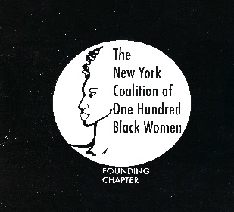

I want to help the New York Coalition of One Hundred Black Women continue to empower women by providing programs and events designed to educate, encourage, assist, and enhance leadership and career development skills. Where needed, I would also want my tax-deductible donation to aide in expanding scholarship opportunities for women entering or continuing the pursuit higher education.

I wish to donate: _____$50 _____$75 _____$100 _____$150 _____$200 _____Other
This payment is for:
_____ General Contribution
_____ Scholarship Program
_____ Membership Dues - year __________
_____ General ($200.00)
_____ Senior ($150.00 – 65 years old and older)
_____ 3-Year General ($525.00)
_____ 3-Year Senior ($375.00 – 65 years old and older)
_____Other (specify)___________________________________________________
You may also contribute by sending a check payable to New York Coalition of One Hundred Black Women to:
Mailing Address: New York Coalition of One Hundred Black Women
Post Office Box 2555
Grand Central Station
New York, NY 10163

Please indicate the reason for donation on the Memo line of the check.

